AI Assisted Problem Solving Using Python

NAME : SYEDA AFIFA FATHIMA
HT.NO : 2503B05142
Program Name: M.Tech (CSE)
Lab 3 : Application for TGNPDCL
Objective:
Build an application using Python program for TGNPDCL, to generate the bill based on energy consumption and type of customer with the help of AI tools. Build a python application as per below instructions
• Read all the required data like PU,CU and Type of customer
• Calculate bill amount based on number of units consumed, type of customer and other charges
• Finally print the values of EC(Energy Charges),FC(Fixed Charges),CC(Customer Char-ges),ED(Electricity Duty Charges),bill as per expected output
Requirements:
• VS Code with Github Copilot and/or Google Colab with Gemini
• Students should bring power bill from their home
Deliverables:
• Print energy bill for given inputs and verify with bill taken by students
Prompt:
Generate a python program for TGNPDCL, to create a bill based on energy consumption and type of customer. Read all the required data like PU,CU and Type of customer , Calculate bill amount based on number of units consumed, type of customer and other charges. Finally print the values of EC(Energy Charges),FC(Fixed Charges),CC(Customer Charges),ED(Electricity Duty Charges) and Total Bill.

CODE:

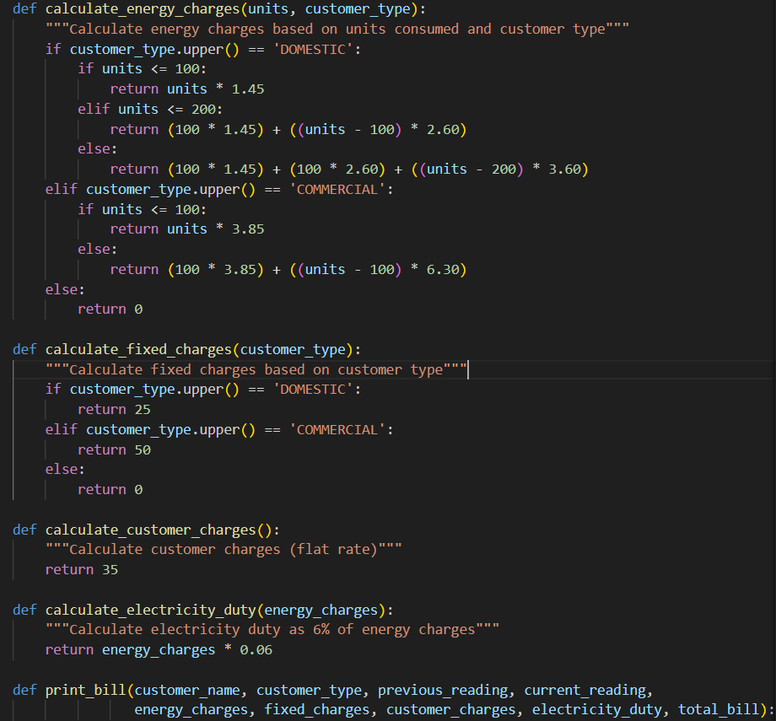
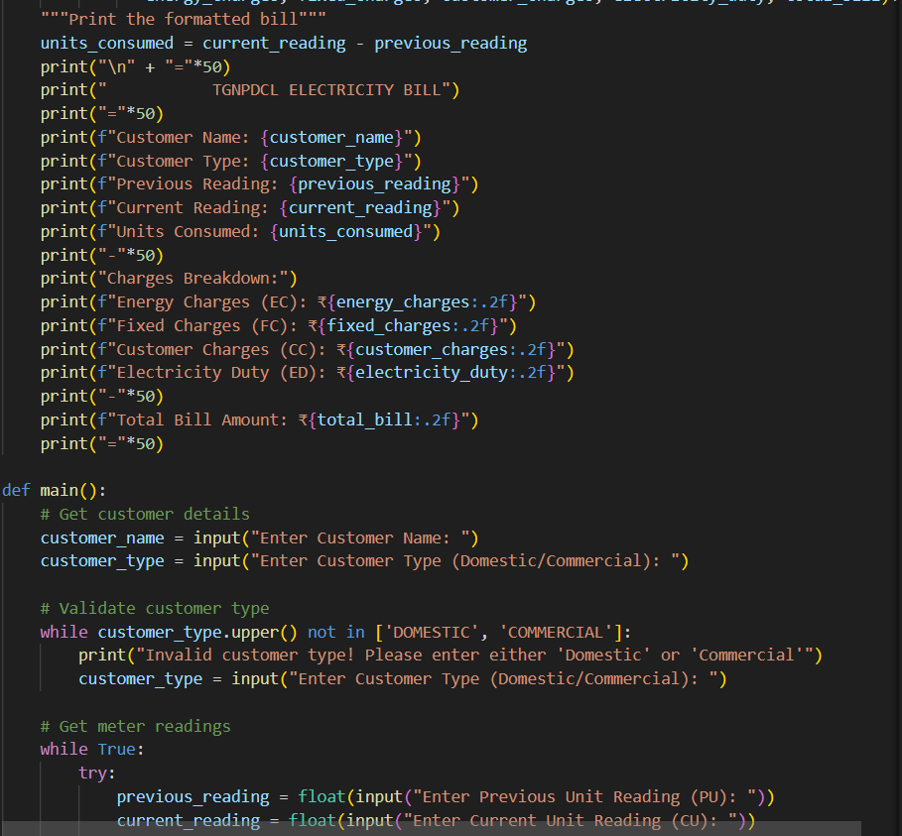
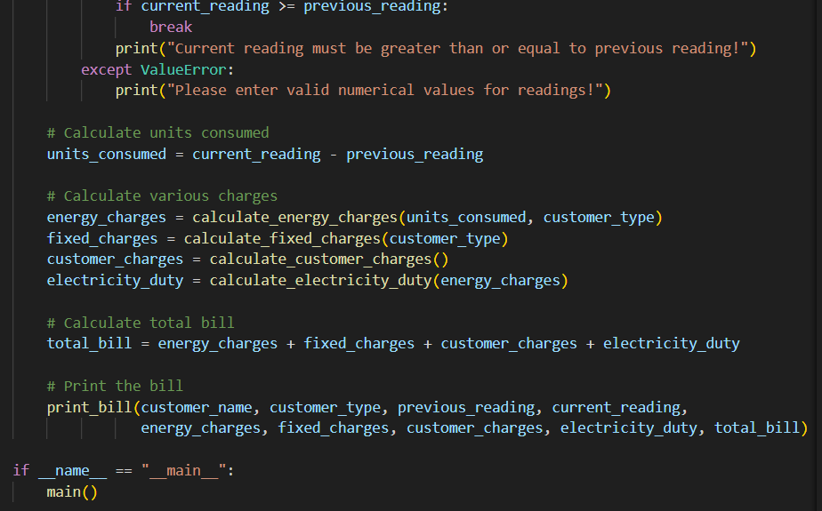

OUTPUT:

